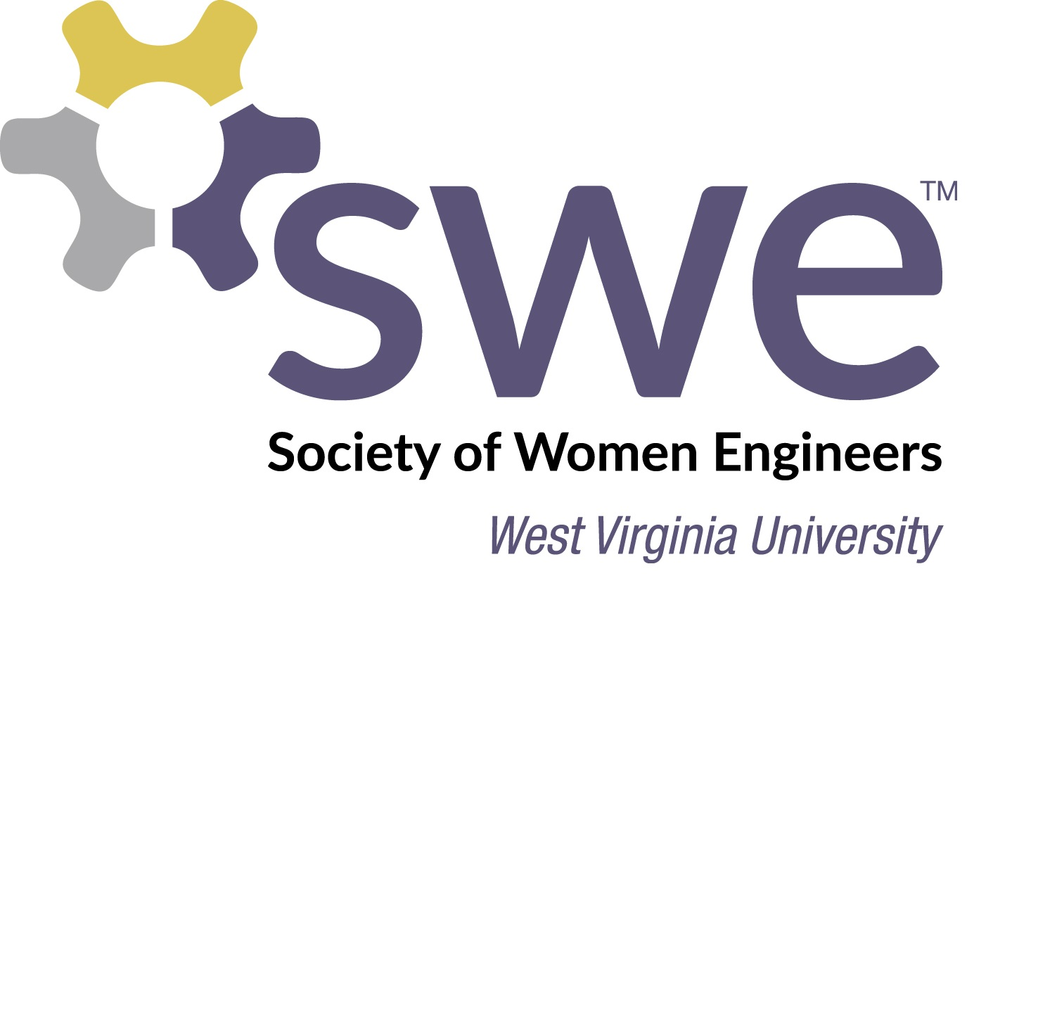

## 

Find us on Facebook: [WVU Society of Women Engineers](https://www.facebook.com/WVUSWE/?fref=ts)

Twitter:@WVU_SWE

Add us on [LinkedIn](https://www.linkedin.com/in/wvu-swe-915b0488?trk=hp-identity-name)!

How Do I Join SWE?

(in order to put SWE on your resume, you must join on the societal level)

1. Sign up: http://societyofwomenengineers.swe.org/membership
2. Click join and select our section number: G 074.
3. There are two membership types, but Collegiate-to-Career includes all of your collegiate career plus your first professional year, so it is the best deal!

Welcome to West Virginia University’s Section of the Society of Women Engineers!

August 2016

Upcoming Events

August

* 24th - First Meeting
* 25th - SWE Welcome Picnic
* 26th-27th - Leadership Retreat

September

* 3rd – SWE Tailgate
* 7th – EngineerFEST
* 9th – Smooch a Pooch
* 14th – Internship OCE
* 17th - SWE Murder Mystery Lunch
* 23rd-24th – Animal Volunteer Event

What is the Society of Women Engineers?

For our first newsletter of the year, we wanted to formally introduce our student organization! The Society of Women Engineers was established in 1950 with a current mission to:

[*Stimulate women to achieve full potential in careers as engineers and leaders, expand the image of the engineering profession as a positive force in improving the quality of life, and demonstrate the value of diversity.*](http://societyofwomenengineers.swe.org/about-swe)

FAST FACTS:

* There are around 35,000 members: both collegiates and professionals
* There are 10 geographic regions represented within the society, with over 300 collegiate and 100 professional sections
* Current objectives are: professional excellence, globalization, and advocacy

More information about SWE can be found [here](http://societyofwomenengineers.swe.org/about-swe).

**WVU SWE Fast Facts**

* 572 service hours
* 400+ K-12 students impacted by outreach events
* 139 members from all 12 Statler disciplines
* 40+ interviews with Fortune 500 companies
* 20+ job offers from conference career fairs
* 19 members in leadership positions
* 5 awards at region and society level
* **Trunk or Treat-** This event is held at the Coliseum every October. Numerous organizations come, dress up, and decorate their areas as they hand out candy to local children!

***You can volunteer for any of these events!***

What events does our section participate in?

* **Murder Mystery Lunch** – This is a SWE sponsored Girl Scout activity, where the event is setup like a game of Clue. Participants must solve a murder based on clues given during different stations through the day.
* **8th Grade Day-** A SWE-sponsored event, where multiple student organizations within the college of engineering help run stations. 8th grade students explore engineering fields through STEM-related activities.
* **Engineering Formal-** This event always wraps up Engineering Week in the spring semester, with a dance for engineering students and their friends!
* **Girl Scout Day-** This is our largest SWE-sponsored outreach event of the year! It is geared for Girl Scouts, daisies to cadettes, to introduce young women to STEM. There are stations set up for the girls to earn a new badge by the end of the day.

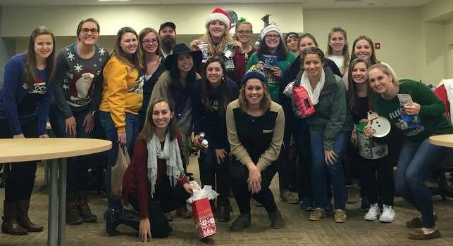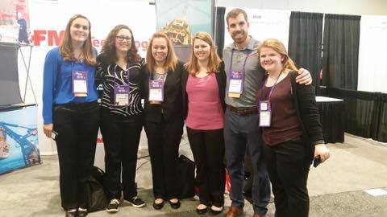

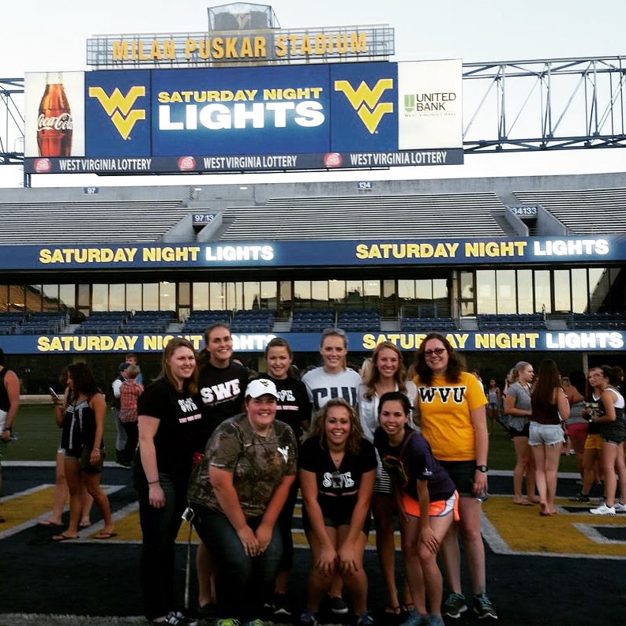

If you have any questions feel free to **email** our SWE account!

[wvuswe@gmail.com](mailto:wvuswe@gmail.com)

* **8th Grade Day Committee-** Help plan this spring event; volunteers are always needed!

**Contact: Rachel Dubriwny**

[radubriwny@mix.wvu.edu](mailto:radubriwny@mix.wvu.edu)

* **Mentoring Program**- Help plan events and work with the mentorship program!

**Contact**: Alex Anderson

[aranderson1@mix.wvu.edu](mailto:aranderson1@mix.wvu.edu)

*If you are interested in volunteering with the **upcoming Murder Mystery Lunch please email** [**aeweiss@mix.wvu.edu**](mailto:aeweiss@mix.wvu.edu) **or kmkutzner@mix.wvu.edu**

Our Committees

We have numerous committees within our section that you can join! If interested, please contact the committee chairs to get involved:

* **Social Events-** Plan social events for our section for the year! (Welcome Picnic, Trunk-or-Treat, fun social events with other SWE sections/student orgs, etc.)

**Contact:** Jenna Henry [jyhenry@mix.wvu.edu](mailto:jyhenry@mix.wvu.edu)

* **Fundraising-** Help plan and run fundraisers for our section! (Sell merchandise, photo fundraiser, etc.**)**

**Contact:** Rachel Ridenour

[raridenour@mix.wvu.edu](mailto:raridenour@mix.wvu.edu)

* **Professional Development-**

Help work with companies to gain sponsorship and plan events with Career Services, other orgs, etc.!

**Contact:** Sabrina Ridenour

seridenour@mix.wvu.edu

* **Community Service**- Help plan or participate in community service events locally within schools or other locations!

**Contact:** Denna Davari

[ddavari@mix.wvu.edu](mailto:ddavari@mix.wvu.edu)

* **Girl Scout Day Committee**- Our biggest event! Help plan and participate in our Girl Scout Day!

**Contact:** Eilish Miller/Ashley Konya

[ekmiller@mix.wvu.edu](mailto:ekmiller@mix.wvu.edu) [aekonya@mix.wvu.edu](mailto:aekonya@mix.wvu.edu)